**Visvesvaraya Technological University**

**Belagavi**



**A Mini Project Report**

**on**

**“FABRICATION OF WATER SPRINKLER AND PESTICIDE SPRAYER”**

***Submitted by***

|  |  |
| --- | --- |
| **C THARUN SAI YADAV,** | **USN:1NH20EC035** |
| **VIMARSHA RUDRESH,** | **USN:1NH20EC183** |

***In partial fulfilment for the award of the***

***degree of***

**BACHELOR OF ENGINEERING**

**IN**

**ELECTRONICS AND COMMUNICATION ENGINEERING**





Bengaluru – 560 103

**DEPARTMENT OF ELECTRONICS AND COMMUNICATION ENGINEERING**

**CERTIFICATE**

Certified that the Mini project entitled “**FABRICATION OF WATER SPRINKLER AND PESTICIDES SPRAYER”** is carried out by **Mr. C Tharun Sai Yadav** bearing **USN: 1NH20EC035** and **Ms. Vimarsha Rudresh** bearing **USN: 1NH20EC183**, bonafide students of NHCE, Bengaluru in partial fulfilment for the award of Bachelor of Engineering in Electronics and Communication of the Visvesvaraya Technological University, Belagavi during the year 2022-23. It is certified that all corrections and suggestions indicated for Internal Assessment have been incorporated in the report deposited in the department library. The mini project report has been approved as it satisfies the academic requirements in respect of the mini project work prescribed for the said degree.

|  |  |
| --- | --- |
|  |  |
| Signature of the guide  Dr. Arun Kumar  Senior Professor  Department of ECE  NHCE, Bengaluru | Signature of the HoD  Dr. Aravinda K  Professor & HoD  Department of ECE  NHCE, Bengaluru |

|  |  |
| --- | --- |
| Name of the Examiner | Signature of the Examiner |
| 1. | 1. |
| 2. | 2. |

**ACKNOWLEDGEMENT**

The satisfaction and euphoria that accompany the successful completion of any task would be impossible without the mention of the people who made it possible, whose constant guidance and encouragement crowned our efforts with success.

We have great pleasure in expressing gratitude to **Dr. Mohan Manghnani**, Chairman, New Horizon Educational Institutions, for providing necessary infrastructure and creating good environment.

We take this opportunity to express our profound gratitude to **Dr. Manjunatha**, Principal, New Horizon College of Engineering, for his constant support and encouragement.

We would also like to thank **Dr. Aravinda K** Professor and HOD, Department of Electronics and Communication Engineering, for his constant support.

We also express our gratitude to **Dr Arun Kumar**, our project guide, for constantly monitoring the development of the project and setting up precise deadlines. Their valuable suggestions were the motivating factors in completing the work.

Finally, a note of thanks to all the teaching and non-teaching staff of Dept of Electronics and communication Engineering, for their cooperation extended to us, and our parents and friends, who helped us directly or indirectly in the course of the project work.

**ABSTRACT**

The construction of a remote-controlled car with a water sprinkler and a pesticide sprayer is described in this study. The goal of this project is to provide a practical and effective method for spraying insecticides and watering plants in expansive gardens or agricultural fields. The remote-control feature gives the user freedom and convenience by enabling remote control operation of the vehicle.

The fabrication procedure include creating a solid chassis that can support the required parts, including the water tank, pump, nozzle, and pesticide container. Electric motors that are connected to the car's wheels allow it to move on its own. The electronics of the car incorporates a remote control module to allow wireless communication and control.

The water sprinkler system consists of a motor-driven pump that sucks water from a tank and pushes it through a network of tubes and nozzles. The strategy ensures even water distribution over a large region, successfully irrigating the plants. The pesticide sprayer system also includes a separate container attached to a spraying motor. This mechanism sprays a fine mist of pesticides uniformly over the plants to shield them against insects and illnesses.

The car can be driven and the water sprinkler or pesticide sprayer can be turned on or off as needed thanks to the remote control feature. The controls include on/off switches for the sprinkler and sprayer operations as well as directional movement (forward, backward, left, and right). The remote control sends signals to a receiver unit in the car, which interprets the user's commands and executing the corresponding actions.

In conclusion, the development of a remote-controlled car equipped with a sprinkler and pesticide sprayer presents a novel approach to effective irrigate and pest management. By fusing robotics with agriculture, this idea offers a practical and efficient way to manage wholesome gardens and crops. Incorporating sensors for automatic obstacle identification and GPS technology for navigation and mapping capabilities are potential future enhancements.

**CONTENTS**

|  |  |  |  |  |
| --- | --- | --- | --- | --- |
| Chapter | |  | Title | Page No |
|  |  |  |  |  |
|  |  |  | List of Figures | v |
|  |  |  |  |  |
| 1 |  |  | Introduction | 1 |
|  |  |  |  |  |
|  |  |  | Literature Review | 3 |
|  |  |  |  |  |
|  |  |  |  |  |
| 3 |  |  | Existing System | 4 |
|  |  |  |  |  |
| 4 |  |  | Proposed System | 5 |
|  |  |  |  |  |
| 5 |  |  | Hardware and Software Specifications | 6-10 |
|  |  |  |  |  |
| 6 |  |  | Working | 11-13 |
|  |  |  |  |  |
| 7 |  |  | Advantages and Applications | 14-15 |
|  |  |  |  |  |
| 8 |  |  | Results and Discussion | 16 |
|  |  |  |  |  |
|  |  |  |  |  |
| 9 |  |  | Future scope and Conclusion | 17 |
|  |  |  |  |  |
|  |  |  | Reference | 18 |
|  |  |  | Appendix | 19-21 |

**LIST OF FIGURES**

|  |  |  |
| --- | --- | --- |
| **Figure** | **Title** | **Page No** |
|  |  |  |
| 3.1 | Irrigation on ground | 4 |
|  |  |  |
| 3.2 | Irrigation via drip | 4 |
|  |  |  |
| 3.3 | Irrigation by hand | 4 |
|  |  |  |
| 5.1 | Sprinkler | 6 |
|  |  |  |
| 5.2 | DC motor | 6 |
|  |  |  |
| 5.3 | Battery | 6 |
|  |  |  |
| 5.4 | Pump motor | 7 |
|  |  |  |
| 5.5 | Water tank | 7 |
|  |  |  |
| 5.6 | Wheels | 7 |
|  |  |  |
| 5.7 | Arduino Uno | 8 |
|  |  |  |
| 5.8 | L298N Motor | 9 |
|  |  |  |
| 5.9 | HS-04 Wifi Module | 9 |
|  |  |  |
| 5.10 | Jumper wire | 9 |
|  |  |  |
| 5.11 | Relay module | 9 |
|  |  |  |
| 5.12 | Buck Module | 10 |
|  |  |  |
| 5.13 | Servo Motor | 10 |
|  |  |  |
| 6.1 | Block diagram | 11 |
|  |  |  |
| 6.2 | Circuit Diagram | 11 |
|  |  |  |
| 6.3 | Working Model | 13 |
|  |  |  |
|  |  |  |
|  |  |  |
|  |  |  |
|  |  |  |

**CHAPTER 1**

**INTRODUCTION**

A water sprinkler robot system employs a robot equipped with a sprinkler or sprayer and a water tank that goes throughout the field spraying water and pesticides. It's similar to a water tank that goes around the field mechanically spraying water and chemicals.

The Robot can be outfitted with geo fence sensors, allowing it to complete fields without needing for human intervention. To achieve proper watering, a huge piping setup and a high number of sprinklers are required.

This system has many problems associated with it. In this pipeline system is always a chance of leakages and high power consumption. We can prevent all these problems in irrigation system by using this new aged robot.

Using insecticides and watering plants are essential in farming and gardening. However, doing these things by hand can be time-consuming, labor-intensive, and inefficient, especially in big gardens or agricultural fields. A workable solution to these issues is the development of a remote-controlled car with a water sprinkler and a pesticide sprayer. By combining the flexibility of remote control technology with the effectiveness of automated irrigation and pest control systems, this concept provides a versatile and efficient approach of plant care.

The objective of this project is to construct a remotely controlled vehicle that can traverse farms or gardens while dispensing water and insecticides as required. A water sprinkler and a pesticide sprayer are included inside the car to streamline the application process. A sturdy chassis capable of holding the car's parts and mechanisms must be designed and built during the fabrication process. The sprinkler system includes a motor-driven pump, a water tank, and a series of tubes and nozzles for even water distribution. The precise and even covering of the plants is ensured by the pesticide sprayer system, which comprises of a separate container coupled to a spraying mechanism.

The water sprinkler and pesticide sprayer functions can be activated remotely thanks to the remote control feature, which is accomplished utilising a wireless communication system. The user may manoeuvre the car to desired areas and start the watering and pest control operations when necessary, which increases convenience and ease of use. This remote-controlled automobile has many benefits. First off, it considerably lessens the need for manual labour, saving time and effort. Compared to manual methods, the automobile is more effective and efficient in covering huge areas. Second, the correct application of water and pesticides guarantees that crops receive appropriate nutrient and protection, producing plants that are healthier and more productive. Last but not least, the remote control capability provides flexibility and adaptability, enabling the user to precisely target problem regions or address particular areas.

In conclusion, the creation of a remote-controlled car equipped with a water sprinkler and pesticide sprayer presents a viable option for enhancing irrigation and pest management procedures in farming and gardening. This is done by fusing the ease of remote control technologies with the efficiency of automated systems.

**CHAPTER 2**

**LITERATURE REVIEW**

|  |  |  |  |
| --- | --- | --- | --- |
| **Title of the paper** | **Author &Year of Publication** | **Outcome** | **Limitation** |
| Fabrication of solar water sprinkler robot | Mayuresh Wankhede, Ashwini Chikhalkar , Bhavana Gajakush , Varsha Devare, Prof H.R.  Nehete05/May-2022 | Workload on the farmers is decreased and health problems also. Successful in constructing robot which can be travelled on rough, uneven surfaces enough load of pump and other equipment | 1) High initial cost for material  And installation and long ROI.  2)Needs lots of space as efficiency is not 100% yet. |
| Design and Fabrication of solar based Bluetooth Controlled Pesticides Sprayer | Akshay Kumar S, K Nikhil Sai, Amith Raju GS, Abhishek N, Manjunath C May 2019 | Control of vehicles is user friendly and it is not very complicated using Bluetooth; hence farmers can easily control the vehicle. Pesticides spraying is a tedious job in agriculture as it requires various protection equipment’s to project the farmers. | The circuit used only for pesticide ,but in our project both pesticide and irrigation. |
| Design and implementation of Pesticides spraying robot using IOT | Ravi Gorapudi, Bhargava Rama Sai Pavan Rudrapaka, Aadi Seshu Valluri  15 June 2020 | A smart Robot System spraying pesticides is controlled through a remote option in an alternative to manual  Fulfilment of cross spray, lessening direct contact to pesticides. | Task can be improved by utilizing a sensor to take note of the soilph value such that use of unnecessary Fertilizers can red |

**CHAPTER 3**

**EXISTING SYSTEM**

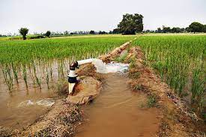**IRRIGATION ON THE GROUND**

There is no mechanical pump involved in the distribution of water over and across land. Irrigation on a localised scale.

Water is provided at low pressure through a piped network to each plant.

**3.1 irrigation on Ground**

**IRRIGATION VIA DRIP**

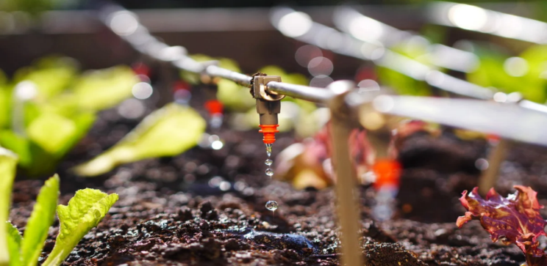 A method of localised irrigation in which water drops are supplied to the root of plants.

Evaporation and runoff are reduced in this method of irrigation.

**3.2 irrigation via drip**

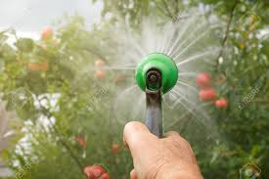**IRRIGATION BY HAND**

Manual labour and watering cans are used to spread water across land. This system is quite time consuming.

**3.3 irrigation by hand**

**LOCALIZED IRRIGATION**

Water is distributed under low pressure, through a piped network and applied to each plant

**CHAPTER 4**

**PROPOSED SYSTEM**

**PROBLEM STATEMENT**

The problem is to design and fabricate a water sprinkler and pesticides sprayer robot for agricultural farms. The robot should move autonomously and perform precise and efficient watering and spraying while considering terrain, crop types, and weather conditions.

**OBJECTIVES**

The water sprinkler and pesticides sprayer robot's goals are to improve watering and pesticide spraying efficiency and accuracy, reduce operational costs, increase crop yields and quality, improve worker safety, provide real-time data on operations, develop a sustainable and cost-effective solution, design an easy-to-operate robot, and ensure environmental friendliness.

**PROPOSED SYSTEM**

The proposed system consists of a remote-controlled car outfitted with a water tank and a spraying mechanism for irrigation and a separate tank and spraying nozzle for pesticide application. The vehicle will be controlled by remote control, and it will have a solid and durable chassis to ensure stability and durability.

the system will be designed with safety features in mind, and the use of pesticides will be regulated to minimize environmental impact. This system's goal is to increase efficiency and reduce manual labour in agricultural and landscaping tasks.

**CHAPTER 5**

**HARDWARE AND SOFTWARE COMPONENTS**

* **SPRINKLER**

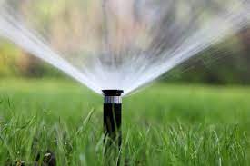

**5.1 Sprinkler**

* **DC MOTOR**

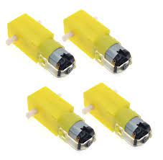

**5.2 Dc motor**

* **BATTERY**

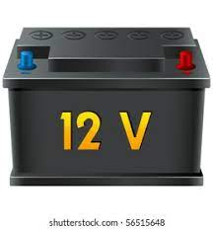

**5.3 Battery**

**PUMP MOTOR**

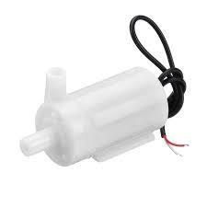

**5.4 Pump Motor**

* **WATER TANK**

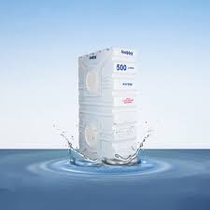

**5.5 Water tank**

* **WHEELS**

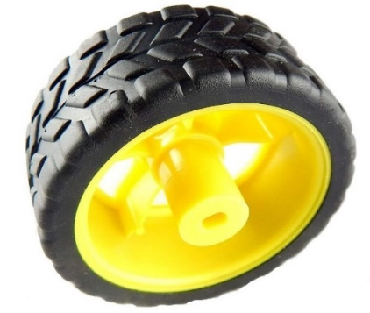

**5.6 Wheels**

* **ARDUINO UNO**

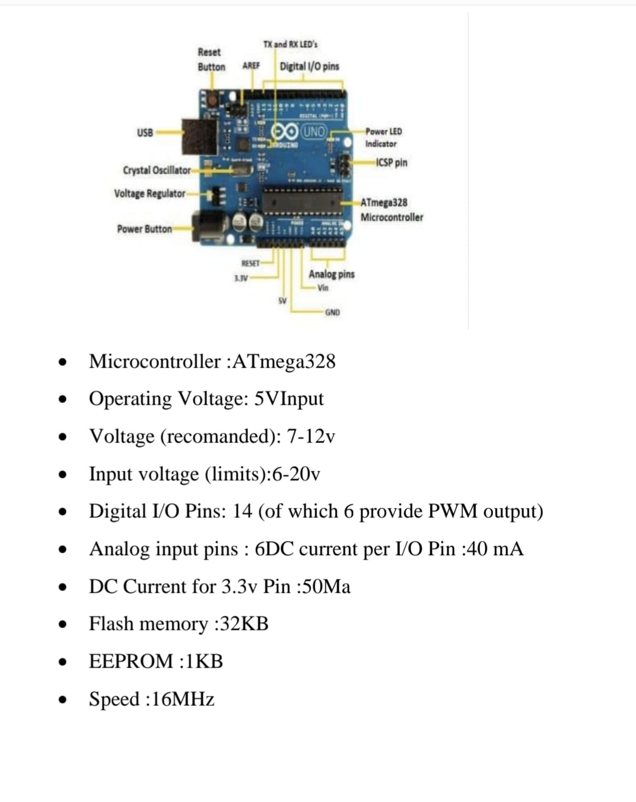

**5.7 Arduino Uno**

**L298N MOTOR**

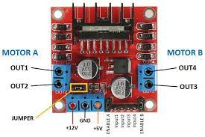

**5.8 L298N Motor**

**HS-O4 WIFI MODULE**

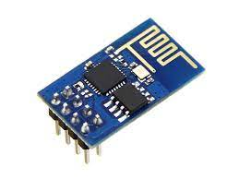

**5.9 HS-04 Wifi Module**

**JUMPER WIRES**

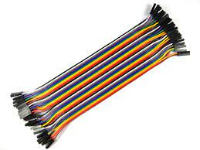

**5.10 Jumper Wire**

**RELAY MODULE**

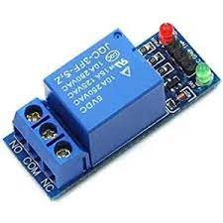

**5.11 Relay Module**

**BUCK COVERTER**

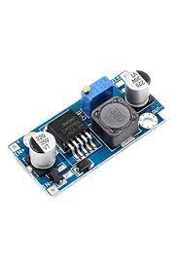

**5.12 Buck Converter**

**SERVO METER**

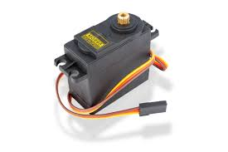

**5.13 Servo motor**

**5.2 Software Components**

**ARDUINO IDE**

**CHAPTER 6**

**WORKING**

1. **Block diagram**

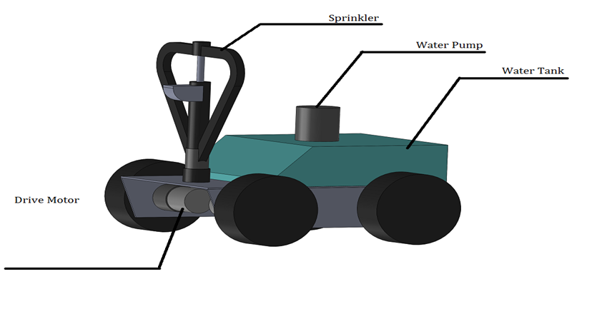

**6.1 Block Diagram**

1. **Circuit diagram**

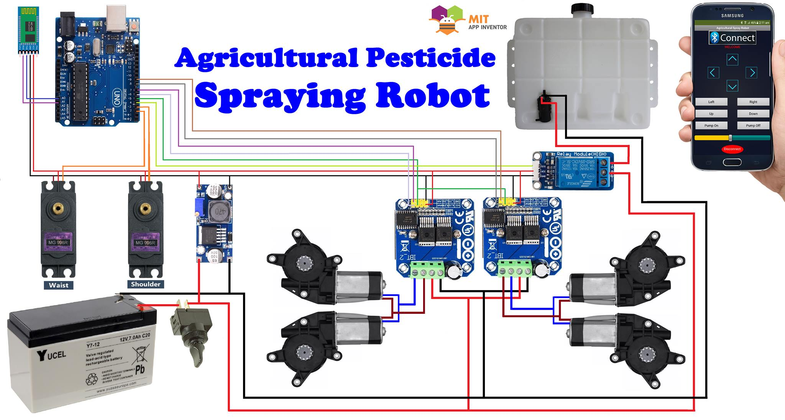

**6.2 Circuit diagram**

A mix of mechanical, electrical, and wireless control systems enable the remote-controlled automobile to spray insecticide and water. The steps that make up this cutting-edge agricultural approach are as follows:

Design and Construction of the Chassis: The fabrication process starts with designing and building a robust chassis that can hold the required components. In addition to housing the propulsion system, water tank, pesticide container, and other systems, the chassis supports the structure. Electric motors built into the car's architecture and attached to the wheels serve as the vehicle's propulsion system. The car can drive across a garden or agricultural area because an electrical circuit controls the motors.

Water Sprinkler System: The water sprinkler system comprises of a motor-driven pump, a water tank, tubes, and nozzles. The tubes, which are placed carefully throughout the body of the car, are propelled through by the pump as it draws water from the tank. Plant watering is uniform thanks to the nozzles' even water distribution over a large region.

Pesticide Sprayer System: The pesticide sprayer system has a separate container attached to a spraying mechanism. The container contains the necessary pesticide solution, and the spraying device emits a fine mist of insecticides. This system makes sure that the plants are evenly covered, guarding them against pests and illnesses.

Integration of Remote Control: The vehicle has a remote control module that permits wireless communication and control. The user can operate the car remotely and turn on the water sprinkler and pesticide sprayer features while standing outside. The receiver module fitted on the car and the remote control device connect wirelessly. Receiving signals from the remote control, the receiver module decodes the user's commands.

Control and Action: The receiver module interprets the commands it receives and starts the associated procedures. Separate switches turn on the water sprinkler and pesticide sprayer functions as needed, while control signals turn on the propulsion system to move in the desired directions.

User Operation: The user uses the remote control to move the vehicle to certain locations and, if necessary, start the watering or pest control processes. Due to the autonomous mobility of the vehicle and the remote control's capability, trouble spots may be targeted quickly and precisely.

Power Source: A rechargeable battery powers the vehicle, ensuring continuous operation during the irrigation and pest control operations. The battery's long-lasting operation is made possible by its rechargeability.

The remote-controlled automobile with a water sprinkler and a pesticide sprayer offers an automated and practical solution for effective plant care by adhering to these operating parameters. The traditional techniques of irrigation and pest management are revolutionised by the use of wireless control, autonomous movement, and accurate application of water and pesticides, increasing agricultural and gardening output and resource efficiency.

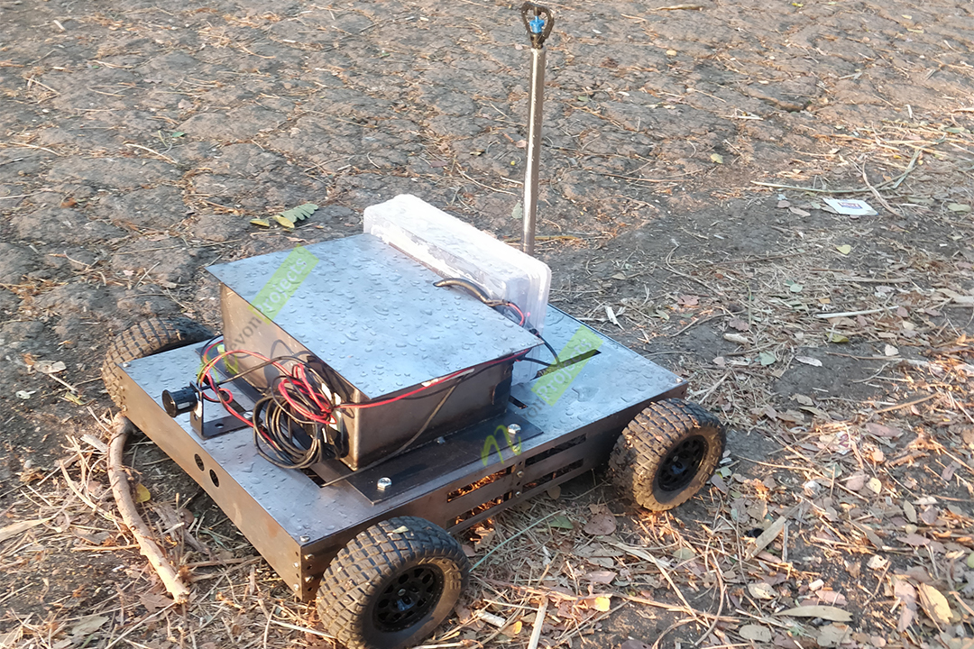

**6.3 Working Model**

**CHAPTER 7**

**ADVANTAGES AND APPLICATIONS**

**7.1) ADVANTAGES**

Efficiency Gained: The remote-controlled automobile equipped with a pesticide and water sprinkler considerably improves plant care efficiency. Comparing automated to manual methods, the automated system covers more regions in less time, requiring less labour and producing more work overall.

Time-saving: The watering and pest management procedures are automated, saving farmers and gardeners a lot of time. To better manage their time and enhance emphasis on other important parts of plant care, they can handle other activities while the automobile drives itself.

A precise and consistent application of water and pesticides is made possible by the technology. The water sprinkler and pesticide sprayer systems are made to disperse water and chemicals uniformly, minimising waste and maximising treatment efficacy. Healthier plants result from this accuracy, and improved crop yields.

Freedom and Targeted Operation: The remote control capability gives the operator freedom and control over the motions and operations of the car. Targeting regions that need additional water or pesticide treatment, users can easily guide the automobile to precise locations. This focused operation enables individualised treatment based on the unique requirements of the plant.

Cost-Effective: The advantages of the remote-controlled car are affordable. Over time, it lowers the need for manual labour and lowers labour expenses. Additionally, the technology minimises waste for effective resource utilisation and cost savings by applying water and insecticides accurately.

Reduced Chemical contact: By reducing direct human contact to pesticides, the remote-controlled car offers a safer alternative. Remote control of the pesticide sprayer allows for operator control, lowering any potential health concerns from handling chemicals. Farmers and gardeners may operate in a safer environment thanks to this.

Scalability: The technology is flexible enough to accommodate gardens or fields of various sizes. The remote-controlled car can be altered and tailored to fit the particular requirements and limitations of the area, whether it is being utilised in compact gardens or vast agricultural lands.

Improved Plant Health and Crop Quality: The correct administration of water and pesticides ensures the best possible plant health and protection. It reduces the possibility of under- or overwatering and encourages steady development. The protection of plants from damaging insects or diseases is another benefit of efficient pest control, which leads to healthier crops and increased crop quality in general.

Future Improvements: The remote-controlled car offers a framework for subsequent improvements and technical progress. The system's capabilities and effectiveness can be further increased by adding further features like sensors for automatic obstacle identification, GPS for navigation and mapping, or connections to data analysis systems for improved plant care.

**7.2)** **APPLICATIONS**

There are numerous uses for the remote-controlled automobile equipped with a water sprinkler and a pesticide sprayer in various industries.

Large-scale farming enterprises can use it to automate the irrigation and pest control procedures, maximising water efficiency and minimising labor-intensive human labour.

The automobile is an effective way for business landscaping to maintain gardens and parks, providing lush, healthy plants. It is useful in greenhouse farming as well, automating the chores of applying pesticides and watering plants to promote better crop growth. It can also be used to effectively control turf irrigation on athletic fields and golf courses.

The remote-controlled automobile is a convenient and adaptable plant care tool for the horticulture, agriculture, landscaping, and leisure industries.

**CHAPTER 8**

**RESULTS AND DISCUSSION**

The remote-controlled vehicle equipped with a pesticide and water sprinkler produced encouraging results in plant care applications. Water was distributed effectively throughout the target area by the irrigation system, guaranteeing uniform coverage. Reduced cases of overwatering or underwatering resulted in better plant health and development. A healthier plant and higher crop yields were produced as a result of the accurate application of pesticides using the sprayer mechanism.

The car could be easily manoeuvred thanks to the remote control capability, enabling focused treatment in certain fields or gardens. This customization reduced resource waste and optimised plant care procedures, increasing the efficacy of irrigation and pest management.

The remote-controlled automobile also provided considerable labour and time savings. The automation of pesticide and irrigation application decreased the need for physical labour, giving farmers and gardeners more time to devote to other crucial duties. This improved the effectiveness and productivity of plant care activities overall.

Overall, the findings show how well resource management, pest control, and irrigation are improved by the remote-controlled automobile equipped with a water sprinkler and a pesticide sprayer. With the use of this technology, plant care procedures can be enhanced in horticulture, agriculture, and landscaping, which will ultimately result in higher crop yields and long-term plant health.

**CHAPTER 9**

**CONCLUSION AND FUTURE SCCOPE**

**9.1 CONCLUSION**

A practical and effective method for irrigation and pest management in agriculture and gardening is the creation of a remote-controlled automobile with a water sprinkler and pesticide sprayer. The system showed capabilities for customisation, precise pesticide application, time and labour savings, and effective water distribution. These benefits contribute to better crop yields, healthier plants, and economical plant care techniques.

**9.2 FUTURE SCOPE**

The remote-controlled automobile system has a number of potential directions for future development and improvement. By integrating cutting-edge sensors for automated obstacle recognition, the vehicle would be able to manoeuvre across difficult terrain and avoid crashes. Additionally, adding GPS technology could offer navigation and mapping capabilities, enabling efficient coverage of vast areas and improved route planning. Additionally, the integration of data analysis tools may make it possible to monitor plant health indices in real-time, enabling prompt intervention and decision-making. Overall, the remote-controlled automobile system has the potential to further revolutionise plant care procedures, support sustainable agriculture.

**REFERENCE**

[1] "Interior Landscape Plants for Indoor Air Pollution Abatement: Final Report", Nation Aeronautics and Space Administration (NASA-TM-101768) Science and Technology Laboratory, Stennis Space Centre, B.C. Wolverton, Anne Johnson, and Keith Bounds, 1989.

[2] "An Autonomous Robot for Harvesting Cucumbers in Greenhouses" by E.J. Van Henten, J. Hemming, B.A.J. Van Tuijl, J.G. Kornet, J. Meuleman, J. Bontsema, and E.A. Van Os; Autonomous Robots; Volume 13 Issue 3, November 2002.

[3] Kevin Sikorski, "Thesis-A Robotic PlantCare System", University of Washington, Intel Research, 2003.

[4] "PotPet: Pet-like Flowerpot Robot", Ayumi Kawakami, Koji Tsukada, Keisuke Kambara, and Itiro Siio, Tangible and Embedded Interaction 2011, Pages 263-264. New York, NY, USA, ACM, 2011.

[5] Mobi Wac '11 Proceedings, Constantinos Marios Angelopoulos, Sotiris Nikoletseas, and Georgios Constantinos Theofanopoulos, "A Smart System for Garden Watering Using Wireless Sensor Networks,"

**APPENDIX**

